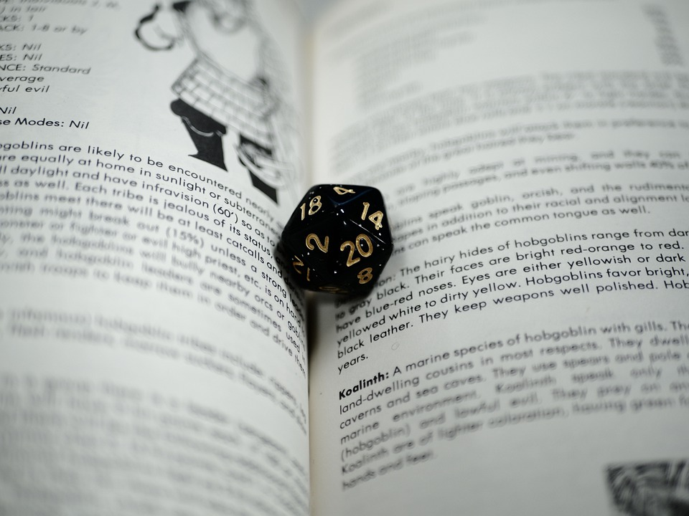

ANNUAL REPORT

2022
The Committee for the Advancement of Role-Playing Games
Email: webmaster@car-pga.org
Website: car-pga.org

TABLE OF CONTENTS
To Our Members 3
Welcome to Our Report 3
Performance Against Our Goals 3
2023 and Beyond 4
Looking Ahead 5
Membership Update 6

To Our Members

Welcome to Our Report
This year was all about building momentum on what we began last year, and those dividends are starting to pay off. We're seeing more and more attention paid to our YouTube channel and an increase in membership applications. We're also getting more interested virtual panelists. And we got an unexpected boost to one of our goals. Here's how we did:

Performance Against Our Goals
- More Virtual Sessions: Our goal was to have at least nine sessions in 2022. We surpassed that goal with 10 sessions, taking off during the summer months. We're now scheduling several sessions out by quarter, and have most of Q1 2023 booked. Overall Score: A.
- Grow the YouTube Channel: Our YouTube channel continues to grow. We gained 28 subscribers (for a total of 46), 473 views (up 146% over last year), with a total watch time of 89.6 hours (an increase of 225% over last year). Because YouTube changed their rules on creating short links, we now have our handle at http://www.youtube.com/@car-pga. Our YouTube channel has definitely come into its own this year, so our Overall Score: A+!
- Increase Our Membership: Our goal was to increase our membership by 12, but we fell short of that with ten new members. Overall Score: B.
- Diversify Our Membership: Our outreach efforts on diversity continue. We plan to focus on more diverse outreach in 2023 and I look forward to engaging guests who can educate us on the DEI space. Overall Score: C.
- Vote: I was disappointed last year to see such low voting for CAR-PGA membership, but I'm hopeful with new members comes more enthusiasm and we'll see more voting in early 2023 for board members. Overall Score: C.

2023 and Beyond
So what are our goals for this year?
- Increase Our Membership: We increased our membership by ten last year, but hoping we can at least grow it by another 12 in 2023, or one new member a month.
- Diversity Focus: The CAR-PGA can be a leader in this space by supporting the diverse work of other creators and we’ll continue to do so. We’ll keep this in mind as we look for guests for our virtual panels. Speaking of which…
- Continue Virtual Sessions: Like last year, our goal was to have at least nine sessions in 2023. That’s probably the most we can manage with the summer break, so we’ll maintain that goal (with some wiggle room in case we have to cancel a session or a guest doesn’t show).
- Grow the YouTube Channel: Our YouTube channel viewership continues to grow. Our end goal is at least 100 members, and we’re well on our way. Given our growth last year, we can hopefully grow by an additional 25 members.
- Grow the Board. As per our by-laws, the CAR-PGA needs at least three board members to operate and can have up to five. But to get to that point, members have to vote. Failure to even vote means the CAR-PGA is not yet self-sufficient, and I consider it a priority that we get to that point if the organization is to survive in 2023 and beyond. Like voting, this is a measure of health of the organization. We should have active voting for board membership, and I look forward to expanding the board to five this year.
“Failure to even vote means the CAR-PGA is not yet self-sufficient, and I consider it a priority that we get to that point if the organization is to survive in 2023 and beyond.”

Looking Ahead
We continued the momentum from 2021 with our virtual panel series in 2022, beginning with prolific artist and author Jim Wampler of Mudpuppy Games. In February I caught up with my friend and author of the solo role-playing game Thousand Year Old Vampire, Tim Hutchings. In March we went back to some of CAR-PGA's roots by interviewing Andrew Wall and discussing the origins of the Satanic Panic. In April, Ben Riggs launched his book, Slaying the Dragon, and we got a sneak peek at what he unearthed in his research about TSR and the early days of Dungeons & Dragons. We then followed that up in May with Savage Hess & Wulf James-Roby about the Coyote & Crow role-playing game; Rick Meints, President of Chaosium, was gracious enough to share his time the following month; followed by Mark Diaz-Truman of Magpie Games in July.

We took a short break for the summer and resumed our rhythm in September with CAR-PGA member and author Christopher Winnan; Christine Resotko of the Confessions of an RPG Nerd blog discussed tabletop gaming and libraries, followed by Dr. Allen White and his model of using RPGs for engineering education. We finished the year strong with Adam Davis of Game to Grow, who does amazing work applying therapy to gaming around the globe.

Whew, that’s a lot! We’ve grown the membership and the YouTube channel in the process, but it feels like we’re just getting started. It’s getting easier to find guests and our efforts are slowly but surely paying off in more engagement with our content. We won’t know if the CAR-PGA is stable until we see if we get a substantial percentage of the population voting for board members, so please look for that next month.

Dungeons & Dragons is becoming more popular than it’s ever been in the history of the game, and the work of the CAR-PGA is even more relevant. I hope we can achieve even more together this year. Thank you for your support!
Michael Tresca
Committee Chair
January 1, 2023

Membership Update
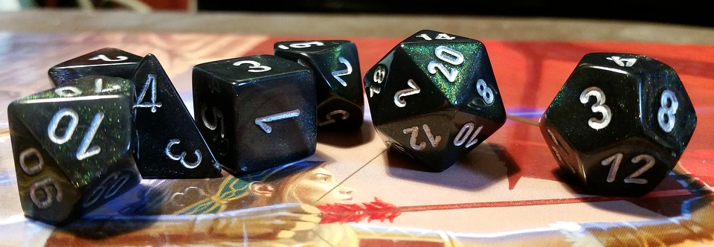

All members listed here have voting rights. If you believe you are a member but aren’t listed, please visit http://car-pga.org/join-us to submit your official application. Feel free to reach out to your colleagues on our LinkedIn or Google groups!

- Aaron Armstrong
- Andrew Greenberg
- Bill Bridges
- Bill Walton
- C.J. Leblanc
- Carsten Obst
- David Millians
- Dom Zook
- Fenway Jones
- Forest Ray
- Hawke Robinson
- Jared Neilsen
- Jenny Hein
- Jeremiah Kaplan
- Jim Wampler
- John Boardman
- John Reyst
- Jon Peterson
- Katie Lear
- Kelly-Jeau Larson
- Kurstin Hamilton
- Lou Zocchi
- Lucio N. Pimentel
- M. Alan Thomas
- Matt Hayward
- Matthew Davies
- Matthew Pook
- Michael Best
- Michael Tresca
- Omar G.L. Diniz
- Robert Adducci
- Ronald Pehr
- Silvia Regina Borges
- Ted Skirvin
- Tim Hutchings
- Timothy Bannock

Please welcome our newest members!

- Alex Grinton
- Allen White
- Andy Heavilin
- Douglas Gardner
- Jeff Richard
- John Welker
- Liz Brown
- Lucio N Pimentel
- Rick Meints
- Wulf James-Roby

